**Assisted Problems**

[GitHub Repository](https://github.com/Nomicy11/BridgeLabz_2115000686/tree/19-Jan)

**1. Welcome to Bridgelabz!**

Write a program that prints "**Welcome to Bridgelabz**!" to the screen.

**2. Add Two Numbers** 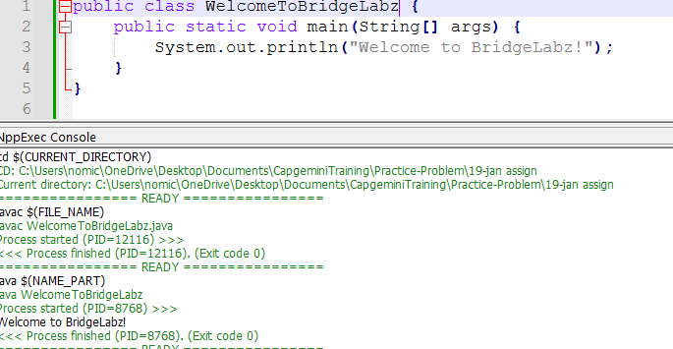

Write a program that takes two numbers as input from the user and prints their sum.

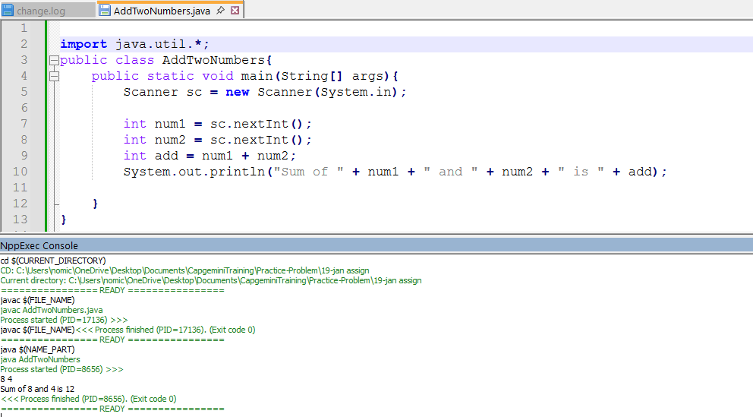

**3. Celsius to Fahrenheit Conversion**

Write a program that takes the temperature in Celsius as input and converts it to Fahrenheit using the formula:

Fahrenheit = (Celsius * 9/5) + 32.

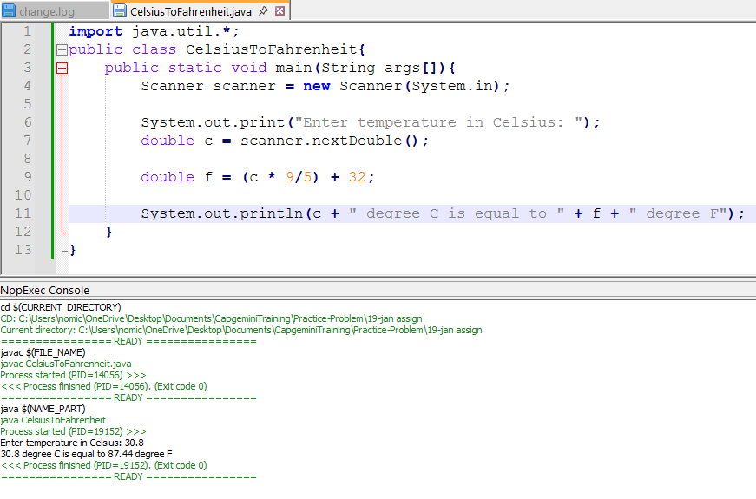

**4. Area of a Circle**

Write a program to calculate the area of a circle. Take the radius as input and use the formula:

Area = π * radius^2.

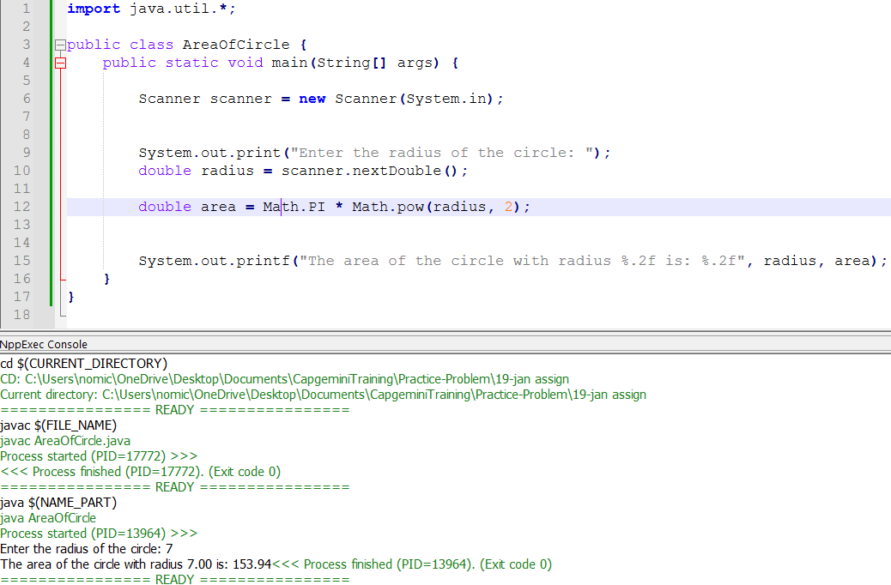

**5. Volume of a Cylinder**

Write a program to calculate the volume of a cylinder. Take the radius and height as inputs and use the formula:

Volume = π * radius^2 * height.

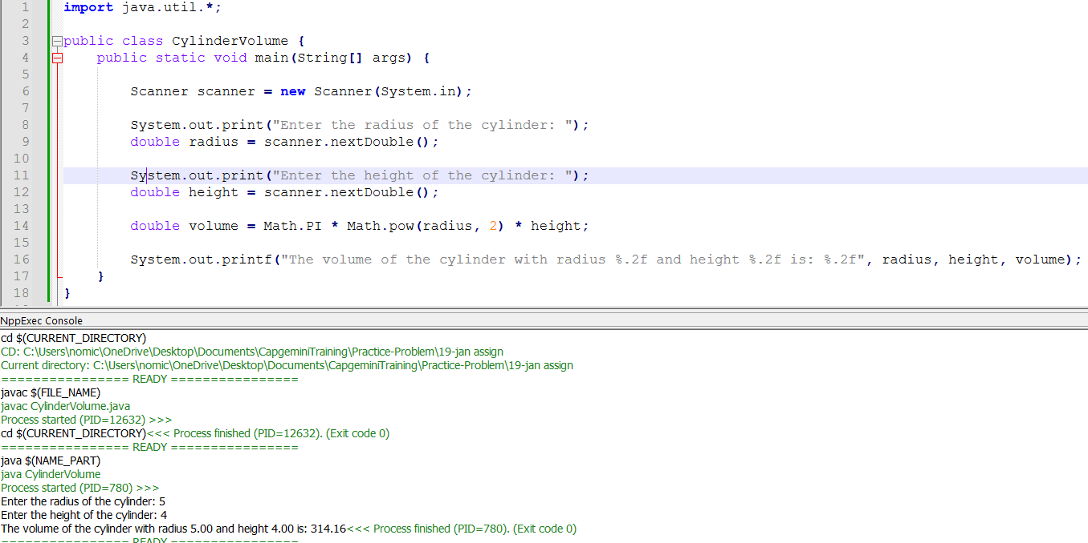

**Self Problems**

**1. Calculate Simple Interest**

Write a program to calculate simple interest using the formula: Simple Interest = (Principal * Rate * Time) / 100. Take Principal, Rate, and Time as inputs from the user.

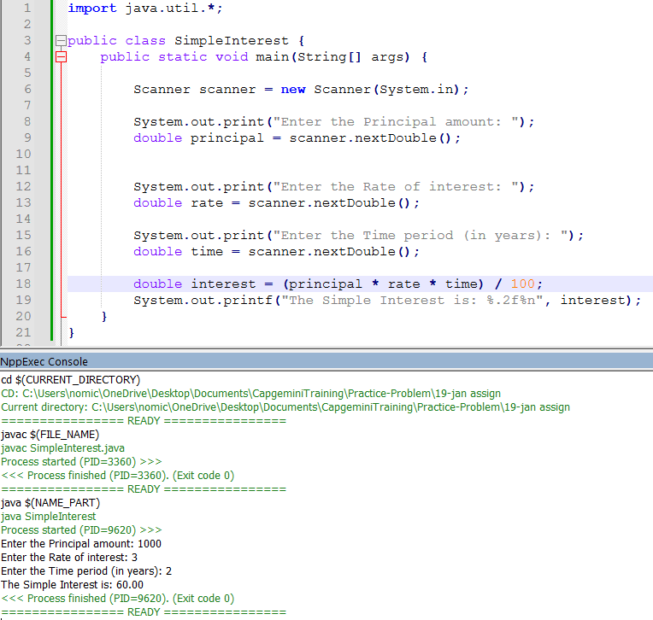

**2. Perimeter of a Rectangle**

Write a program to calculate the perimeter of a rectangle. Take the length and width as inputs and use the formula:

Perimeter = 2 * (length + width).

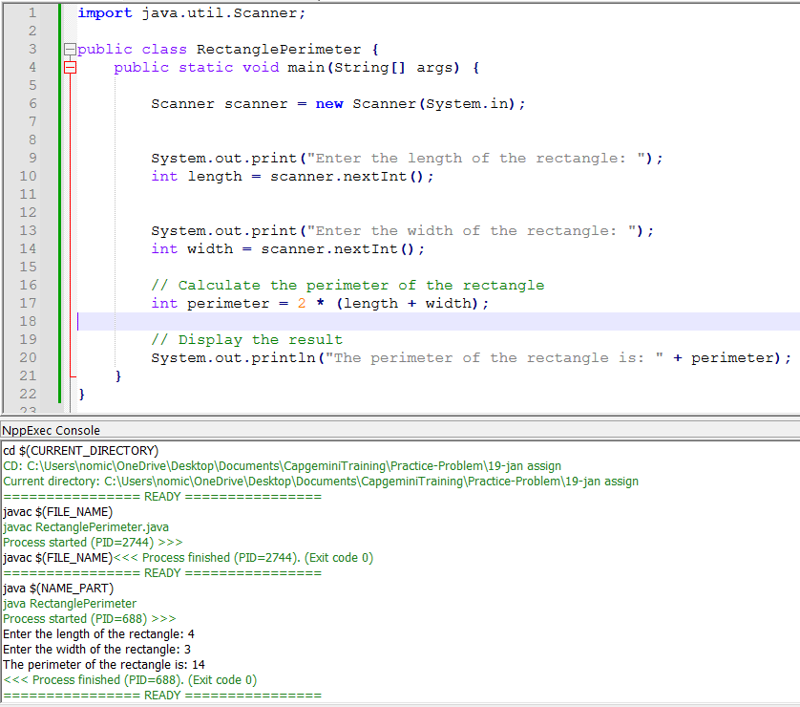

**3. Power Calculation**

Write a program that takes two numbers as input: a base and an exponent, and prints the result of base raised to the exponent (without using loops or conditionals).

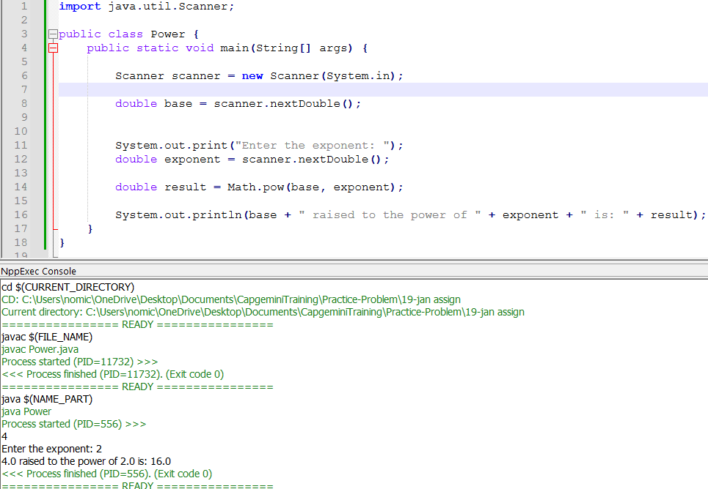

**4. Calculate Average of Three Numbers**

Write a program that takes three numbers as input from the user and prints their average.

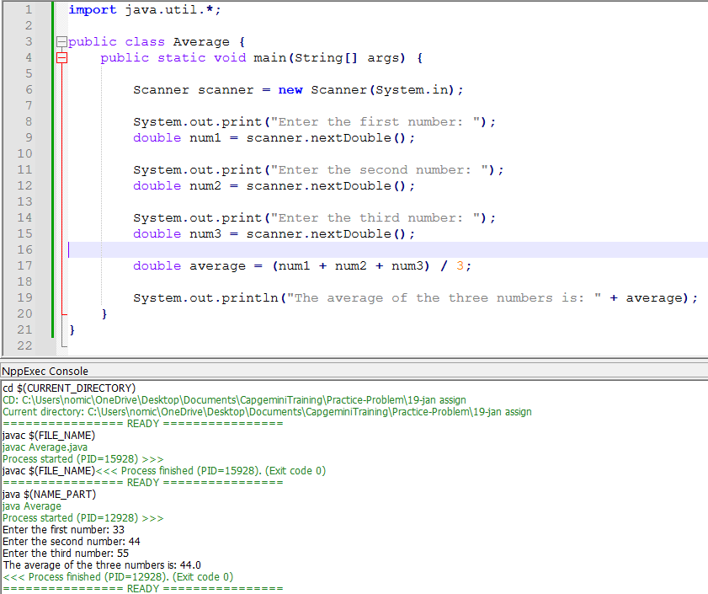

**5. Convert Kilometers to Miles**

Write a program that takes the distance in kilometers as input from the user and converts it into miles using the formula:

Miles = Kilometers * 0.621371.

